**Christian Methodist Episcopal Church**

**Eighth episcopal district**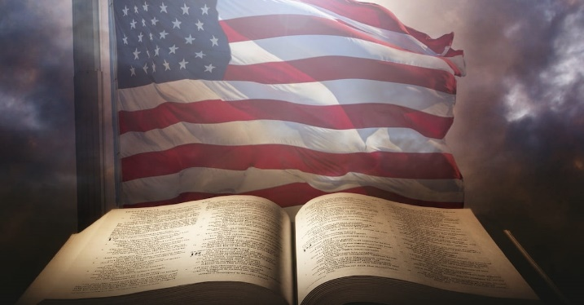

2024

Ministry to Men Retreat

**Thursday, November 14 – Saturday, November 16, 2024**

*Motivational Theme: The Role of Men in a Dying Church: When the Same Old Thing Ain’t Good Enough*

*Revelation 3:1-13KJV*

|  |  |  |  |  |  |  |  |
| --- | --- | --- | --- | --- | --- | --- | --- |
| **REGISTRATION:** $150 [ ] | | **DUE by september 20, 2024** | | | | | |
| ( ) ELDER () REV. ( ) REV. DR. ( ) DR. ( ) MR.  28221c_474e433260d64b15ab8f52cb0263a9edNAME | | | | | ( ) Home ( ) Cell  PHONE | | |
| ADDRESS | | | | | | CITY | |
| ZIP | | | EMAIL | | | | |
| REGION: ( ) Central ( ) Dallas-Fort Worth/NWTX ( ) East ( ) Northwest ( ) Southeast ( ) Jamaica | | | | | | | |
| CHURCH | | | | PASTOR | | | |
| **VISITOR 🞎** | **Episcopal District:** | | **Region:** | | | | **District:** |

CHURCH ROLES/ OFFICERS/MINISTRIES – Mark all that apply.

( ) Pastor ( ) Steward ( ) Children Ministry ( ) Patron Pastor

( ) Associate Pastor ( ) Missionary ( ) Youth Ministry ( ) District

( ) Minister-In-Residence ( ) Trustee ( ) Young Adult Ministry ( ) Region

( ) Local Preacher ( ) Music Ministry ( ) Christian Education ( ) Other

( ) Retired Preacher ( ) Lay Ministry ( ) District Officer

( ) Minister’s Spouse ( ) Usher ( ) Ministry to Men

|  |
| --- |
| **«MAIL** check or money order to: 8th Episcopal District MtM **◊** 2319 Hammerwood Dr. **◊** Missouri City, TX 77489  «Make check / money order **PAYABLE TO:** The Eighth Episcopal District: Ministry to Men  **Using Zelle?** [**8thepiscopalmtm@gmail.com**](mailto:8thepiscopalmtm@gmail.com)  **CashApp: $8thepiscopalmtm Memo: 8th Episcopal MTM Retreat** |

**FOR ADMINSTRATIVE USE ONLY – EIGHTH EPISCOPAL DISTRICT**

|  |  |  |  |  |
| --- | --- | --- | --- | --- |
| **DATE RECEIVED** | **PAID – Method of Payment** | | | |
|  | initial: | ❑ CASH | ❑ CHECK # | ❑ M.O. # |

***8th Episcopal District of the Christian Methodist Episcopal Church ◊ Sr. Bishop Lawrence L. Reddick, III, Presiding Prelate***